**Shiny App User Guide**

**1. Word Cloud**

**Step 1:** Click on the “Word Cloud” tab. This tab contains a Word Cloud and Word Frequency Table generator.

**Step 2a:** Choose a Period from the dropdown list with the following options: “17:00 to <18:30”, “18:30 to <20:30”, “20:30 to 21:34” or “All Periods”

**Step 2b:** If Period has been changed, it is very important to click on the “Update Period” button as this will update the Word Cloud. If this step is not done, only the Word Frequency Table will change but not the word cloud.

**Step 3:** Drag the slider to the desired Minimum Frequency of Words.

**Step 4:** Drag the slider to the desired Maximum Number of Words.

**Inputs (Step 2 to 4)**

**Sample Results**

**2. Network Graph**

**Step 1:** Click on the “Network Graph” tab. This tab contains an interactive Network Graph.

**Step 2:** Select Employee from the drop down list.

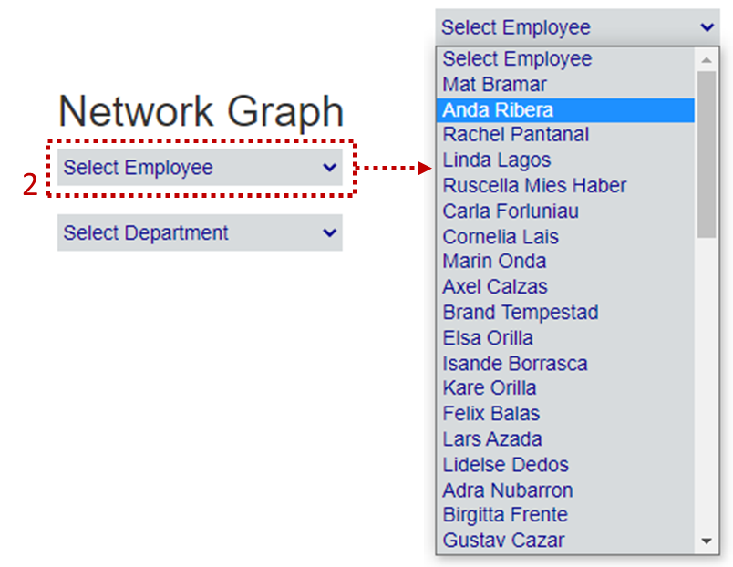

Any other option than “Select Employee” will gray out everyone in the network except for the selected employee and their network. Suppose “Anda Ribera” was selected, the output would then look like this.

Another way of selecting an employee would just be to click on any employee on the graph.

Suppose the employee on the graph in the dotted red circle was clicked on, the employee will be selected and users can see which employee was chosen in the “Select Employee” dropdown list.

**Step 3:** Suppose the user wants to see all the employees in a certain department. They will have to select a department from the “Select Department” dropdown list.

Any other option than “Select Department” will gray out everyone in the network except for the employees in the selected department. Suppose “Executive” was selected, the output would then look like this.

**Step 4:** Observe links by hovering over or clicking on them.

When clicking on a link, the link will turn red. The output would look like this.

When hovering over the link, the any previous selected links will stay but the link hovered over will turn darker gray.

**3. Location Bar Chart**

**Step 1:** Click on the “Location Bar Chart” tab. This tab contains an interactive Bar Chart generator..

**Step 2:** Select Location from the drop down list.

Suppose “Abila Zacharo” was chosen, the output will look like this.

**Step 3:** By hovering over the bars, the day and frequency tooltip will appear. In the example below, the bar for Monday was hovered over.

**Step 4:** There are other interactions available on the top right as follows:

a) Click the camera symbol to download a .png of the bar graph.

b) Click the magnifying glass symbol to zoom in on the bar graph.

Double click to zoom back out.

c) Click the pan symbol and then click and hold on the bar graph to pan to where the user wants to observe.

d) Click the box symbol to select bars using a draggable box. All unselected bars will be greyed out.

e) Click the lasso symbol to select bars to observe using a draggable box. All unselected bars will be greyed out.

f) Click the plus symbol to zoom in.

g) Click the minus symbol to zoom out.

h) Click the autoscale symbol to reset any zoom in or outs and panning.

i) Click the home symbol to reset axis.

j) Click the spikeline symbol to toggle or deactivate spikelines that will appear while hovering over the bars.

k) Click the hover symbol to toggle or deactivate tooltip that will appear while hovering over the bars.

l) Click the compare symbol to toggle comparison on hover.

m) Click the plotly symbol to go to the plotly website to find out more about interactive visualisations.